R DATA VISUALIZATION – SETS 4
Ayesha Siddiqa S
192324305
SET 4: PRODUCT INVENTORY MANAGEMENT
1. Bar Chart – Quantity of Each Product
Aim
To create a bar chart to visualize the quantity available for each product.
Algorithm
1. Create vectors for product names and quantities.
2. Use barplot() to create the bar chart.
3. Add axis labels and a title.
4. Display the chart.
Code
product <- c("Product A", "Product B", "Product C", "Product D", "Product E")
quantity <- c(250, 175, 300, 200, 220)
barplot(quantity,
names.arg = product,
col = "skyblue",
xlab = "Product",
ylab = "Quantity Available",
main = "Product Inventory")
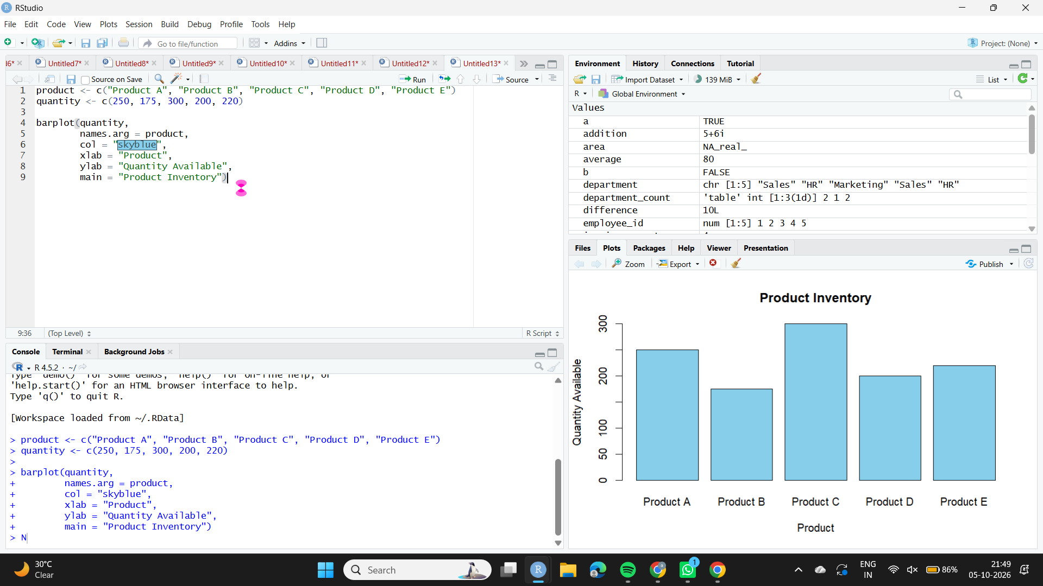

Observation
Product C has the highest quantity (300), while Product B has the lowest quantity (175).

2. Stacked Bar Chart – Products by Category
Aim
To create a stacked bar chart showing product quantities within different product categories.
Algorithm
1. Create product, quantity, and category vectors.
2. Separate quantities by category.
3. Create a matrix for the stacked bar chart.
4. Use barplot() with beside = FALSE and add a legend.
Code
product <- c("Product A", "Product B", "Product C", "Product D", "Product E")
quantity <- c(250, 175, 300, 200, 220)
category <- c("Electronics", "Electronics", "Furniture", "Furniture", "Stationery")
data <- matrix(0, nrow = 3, ncol = 5)
data[1, category == "Electronics"] <- quantity[category == "Electronics"]
data[2, category == "Furniture"] <- quantity[category == "Furniture"]
data[3, category == "Stationery"] <- quantity[category == "Stationery"]
colnames(data) <- product
rownames(data) <- c("Electronics", "Furniture", "Stationery")
barplot(data,
beside = FALSE,
col = c("orange", "lightgreen", "skyblue"),
xlab = "Product",
ylab = "Quantity Available",
main = "Inventory by Product Category",
legend.text = TRUE)
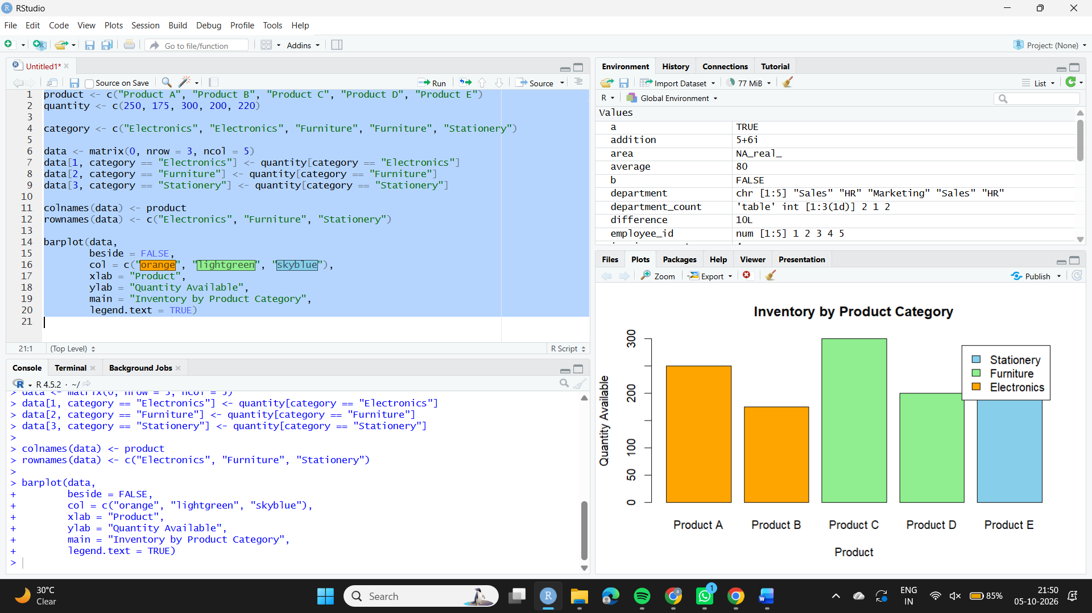
Observation
The stacked chart displays the quantity of each product by category. The original dataset did not provide categories, so sample categories were used.

3. Scatter Plot – Product Price vs Quantity
Aim
To explore the relationship between product price and quantity available using a scatter plot.
Algorithm
1. Create vectors for product prices and quantities.
2. Plot price on the X-axis and quantity on the Y-axis.
3. Add a regression line.
4. Add labels and a title.
Code
product <- c("Product A", "Product B", "Product C", "Product D", "Product E")
price <- c(100, 150, 80, 120, 90)
quantity <- c(250, 175, 300, 200, 220)
plot(price, quantity,
pch = 19,
col = "red",
xlab = "Product Price",
ylab = "Quantity Available",
main = "Product Price vs Quantity")
abline(lm(quantity ~ price),
col = "blue",
lwd = 2)
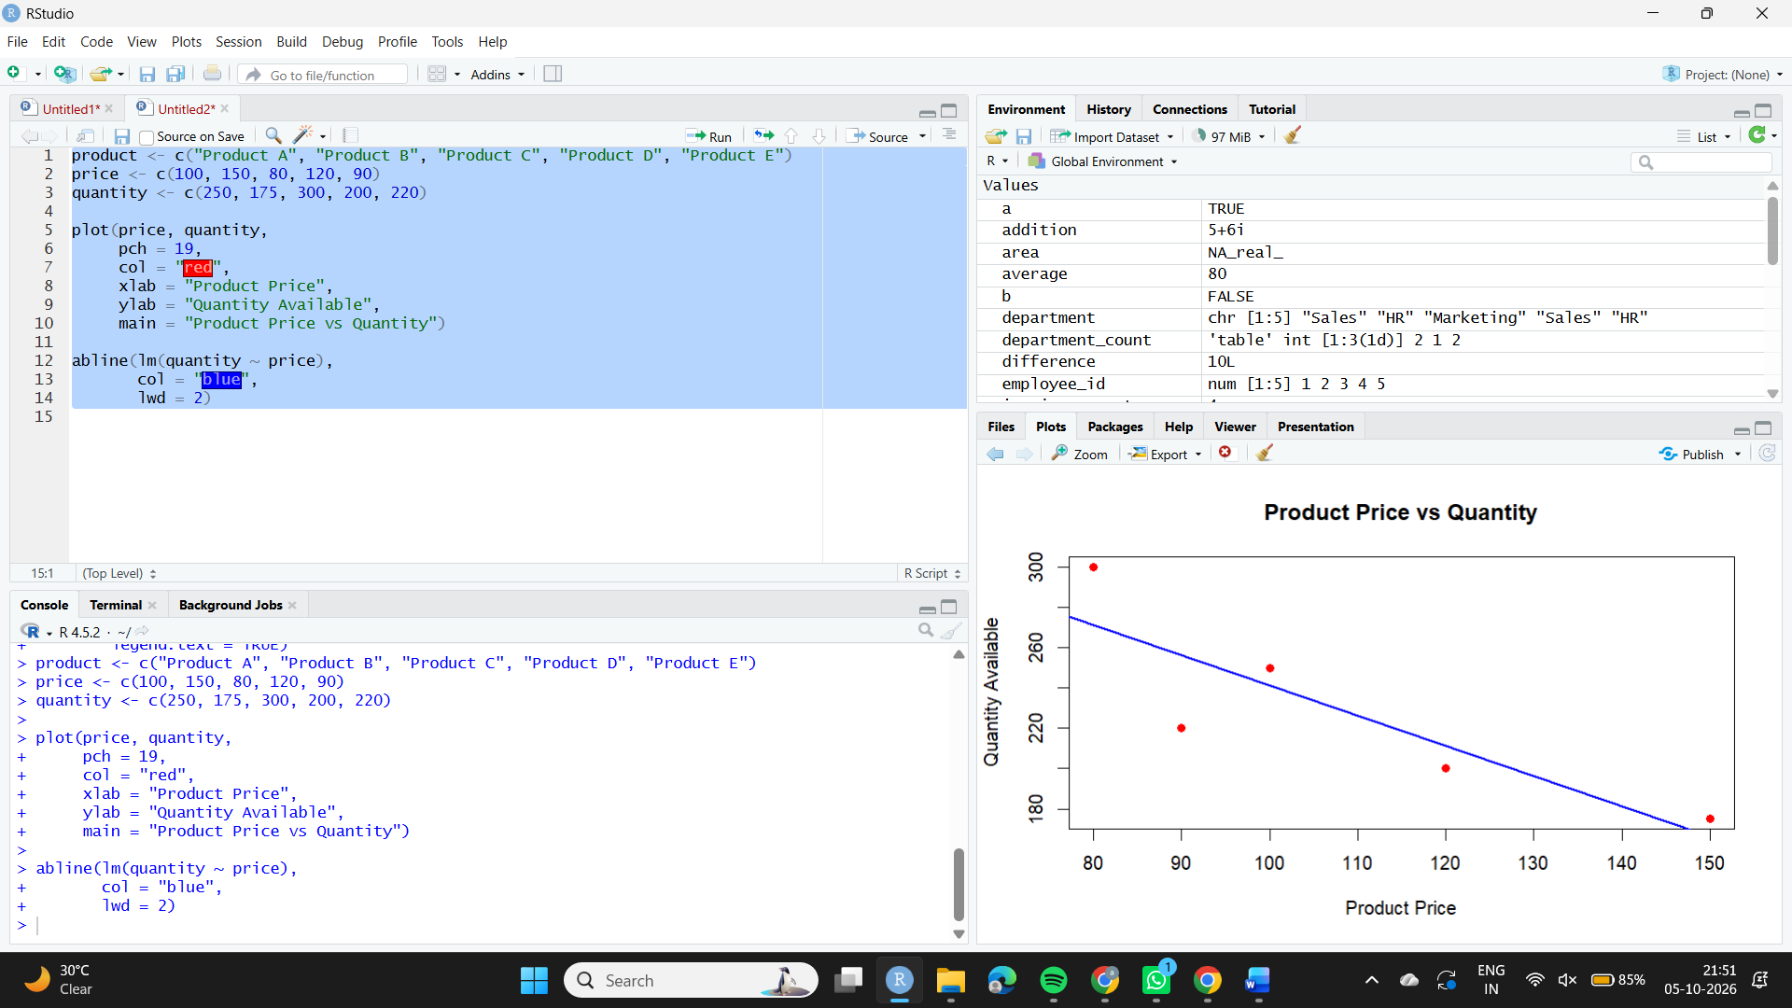
Observation
The sample data suggests a negative relationship: higher-priced products tend to have lower available quantities. Prices were not given in the original dataset, so sample prices were used.

4. Tableau Dashboard
Aim
To develop an interactive Tableau dashboard combining the bar chart and stacked bar chart.
Algorithm
1. Create an Excel or CSV file with the inventory data and category column.
2. Connect the file to Tableau.
3. Create a product quantity bar chart.
4. Create a category-wise stacked bar chart.
5. Create a dashboard and add both charts.
6. Add filters for interaction.
Code
Create the two sheets in Tableau and place them on a new Dashboard. Add Product or Category as a filter.
Observation
The dashboard allows users to compare inventory quantities and explore products by category interactively.

